Accessible Communication for Online Meetings

Guidance and suggested practices for making online sessions accessible and inclusive for persons with complex communication access needs

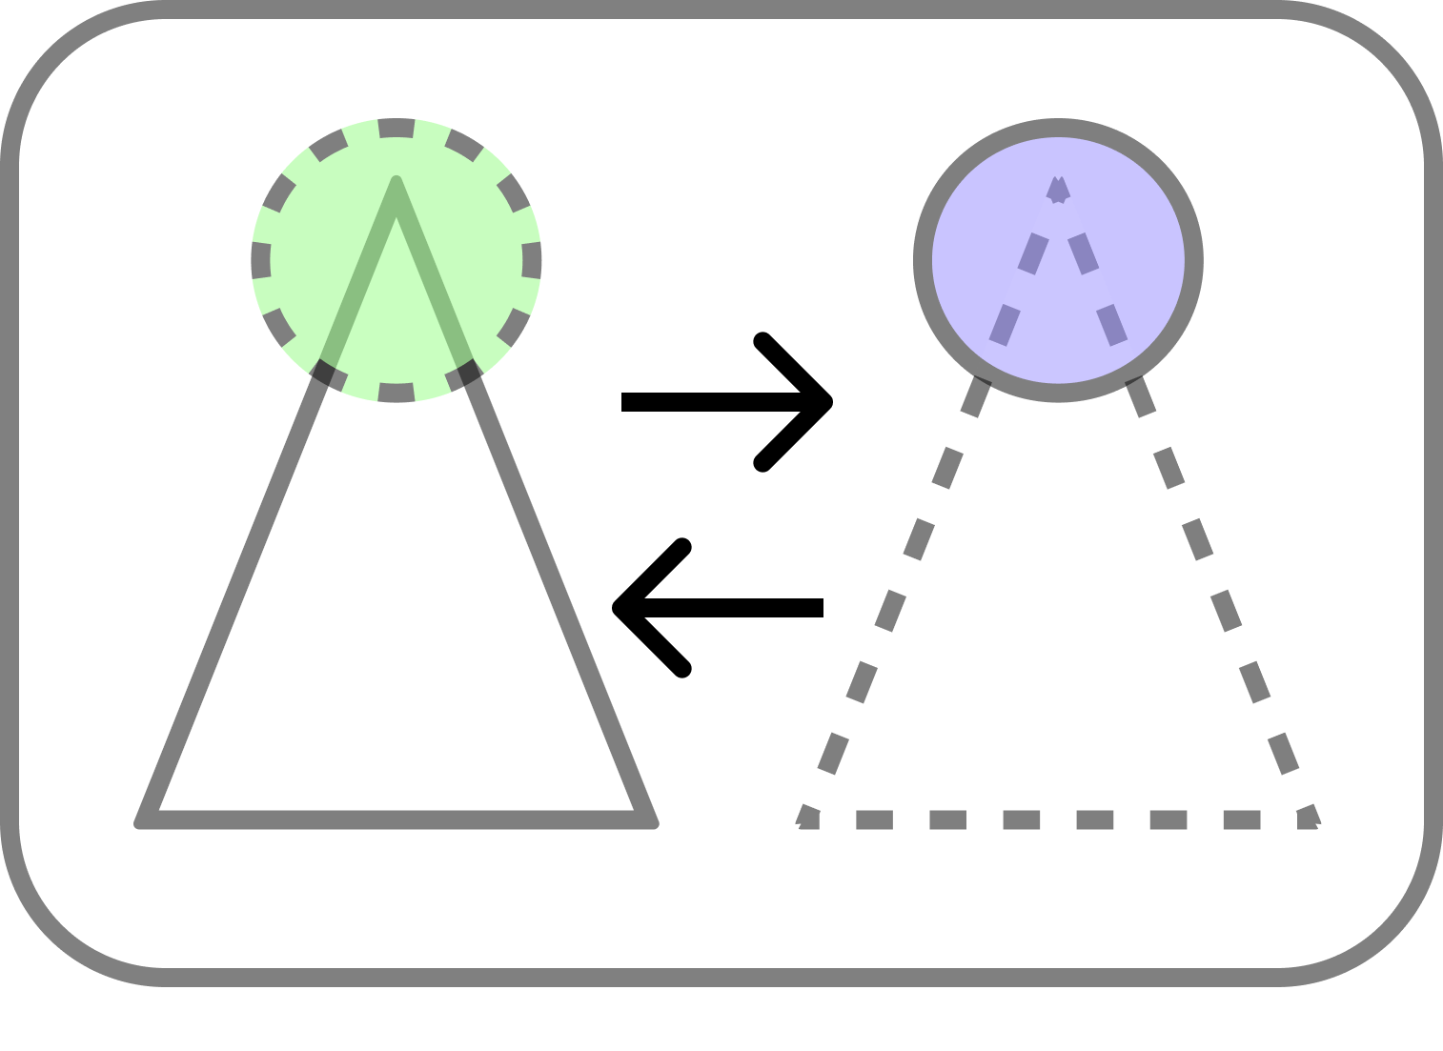

# 

Last updated:

November 2023

About this document

This guidance is intended to guide meeting organizers, presenters, moderators and chat box readers in providing accessible and inclusive online meetings, webinars and presentations for persons who have disabilities affecting their communication and who may or may not use Augmentative and Alternative Communication (AAC).

The development of this guidance document involved an ongoing dialogue with individuals who have complex communication access needs, ensuring that their insights and feedback directly shaped the document’s content. Continuous improvement will be driven by community feedback, ensuring the guidance remains responsive to the evolving landscape of communication accessibility in online meeting spaces.

Copyright notice

This work is licensed under Attribution-NonCommercial 4.0 International (CC BY 4.0). To view a copy of this license, visit <http://creativecommons.org/licenses/by-nc/4.0/>

**You are free to:**

Share — copy and redistribute the material in any medium or format

Adapt — remix, transform, and build upon the material

The licensor cannot revoke these freedoms as long as you follow the license terms.

**Under the following terms:**

Attribution — You must give appropriate credit, provide a link to the license, and indicate if changes were made. You may do so in any reasonable manner, but not in any way that suggests the licensor endorses you or your use.

NonCommercial — You may not use the material for commercial purposes.

**Notices:**

You do not have to comply with the license for elements of the material in the public domain or where your use is permitted by an applicable exception or limitation. No warranties are given. The license may not give you all of the permissions necessary for your intended use. For example, other rights such as publicity, privacy, or moral rights may limit how you use the material.

Table of Contents

**Using an accessible and inclusive online meeting process 4**

**Communication access support protocol for online sessions 5**

Phase 1. Choosing an accessible platform 5

Phase 2. Before the event 7

Scheduling the meeting 7

Registering for the meeting 7

Preparing for the meeting 9

Phase 3. Joining the event 10

Entering the meeting 10

Phase 4. During the event 11

Participating in the meeting 11

Preparing to leave the meeting 13

Phase 5. After the event 14

Participating after the meeting 14

#### 

## Using an accessible and inclusive online meeting process

This research found that for people with complex communication access needs (CCAN), there are various steps involved when accessing online meetings. Likewise, many of the steps overlap with the steps that meeting organizers take when designing and organizing these meetings. The identified steps of an accessible and inclusive online meeting process can be grouped into 5 core phases and subphases:

1. Choosing an accessible platform
2. Before the event

* Scheduling the meeting
* Registering for the meeting
* Preparing for the meeting

1. Joining (connecting to) the event

* Entering the meeting

1. During the event

* Participating in the meeting
* Preparing to leave the meeting

1. After the event

* Participating after the meeting
* Sharing feedback about the meeting

These phases make up the online meeting process; however, more phases may exist. Within each of these phases, we identified a range of communication access needs and barriers among co-designers with CCAN and different levels of accommodations and support that are needed in each phase. In addition, we identified their personal “setup” for attending a meeting which includes their communication devices and software, and any additional equipment and human support they may need to effectively communicate and participate.

## Communication access support protocol for online sessions

Based on the collective contributions and feedback from co-designers with complex communication access needs (CCAN) and community members who organize and lead online meetings, we co-created a protocol and checklist of suggested practices for supporting communication access and inclusion before, during, and after online meetings. The purpose of this community-designed protocol is to provide guidance to meeting organizers, moderators, presenters, and chat box readers when meeting on video conferencing platforms, and using any associated tools in the setup or facilitation of the online meeting. The protocol provides a roadmap on how to support diverse communication needs and help eliminate barriers for persons with CCAN at each of the 5 phases when accessing online meetings.

### Phase 1. Choosing an accessible platform

This section provides a comparative breakdown of accessibility features that are important to people with CCAN, which meeting organizers should be mindful of when choosing an accessible platform. Table 1 below evaluates a range of accessibility features that people who use augmentative and alternative communication (AAC) may require, such as options for typing, captioning, chat box, raised hand and keyboard equivalents for mute and unmute (NAACA, n.d.).

Table 1. Accessibility features and meeting controls across platforms[1]

| Accessibility features | Webex | MS Teams | Google Meet | Zoom | Jitsi Meet |
| --- | --- | --- | --- | --- | --- |
| Keyboard shortcut  (End a call) | Yes | Yes | No | Yes | No |
| Host can mute/unmute participants | Yes | Yes | No | Yes[2] | No |
| Automatic captions | Yes | Yes | Yes | Yes/No[3] | No[4] |
| Live transcript and chat saved | Yes | Yes | No[5] | Yes | No |
| Real-time translations | Yes | Yes | Yes | Yes | No |
| Show/hide the menu/control bar | Yes | Yes | Yes | Yes | Yes |
| Enter meeting with another device | Yes | Yes | Yes | No | No |
| Share screen while seeing all meeting participants | No | No | No | Yes[6] | No |
| One-click sign-in (automatic entry) | Yes | Yes | Yes | Yes | Yes |
| Adjust size and layout of chat panel and text area | No | No | No | No | No[7] |
| Reply directly to a comment | Yes | Yes | No | No | No |

### Phase 2. Before the event

There are three steps for meeting organizers to keep in mind when designing an accessible invitation: scheduling, registering, and preparing. The following sections provide organizers with an overview of accessibility considerations and associated checklists to aid in this process.

#### 2A. Scheduling the meeting

**Accessibility barrier:** Lack of time to schedule and plan for the meeting event

**Communication support need:** A person with CCAN may need time alone to rearrange their schedules when meetings are booked at the last minute; are on the same day as a pre-existing appointment; and/or conflict with personal care appointments. Otherwise, they may not be able to attend the meeting at all.

| Access suggestions and support strategies (checklist) |
| --- |
| * Avoid scheduling last-minute meetings. Consider scheduling meetings in advance to avoid scheduling conflicts. * Choose an accessible platform. Consider choosing a meeting platform with ample keyboard shortcuts, and ideally a platform with single-click access to the meeting space. You might also consider sharing the platform’s list of keyboard shortcuts with participants ahead of the meeting. |

#### 2B. Registering for the meeting

**Accessibility barrier:** Difficulty completing online registration questionnaires

**Communication support need:** A person with CCAN may need help from a communication support person to complete long, technical, and complicated registration forms. Others may require simpler questions on registration forms to support their understanding. In some cases, people with speech, language, and communication disabilities, such as aphasia, may need certain terms and/or vocabulary in the form of pictures or symbols to understand and complete questionnaires.

| Access suggestions and support strategies (checklist) |
| --- |
| * Simplify registration questionnaires. Consider simplifying the language, length, question format, and layout of your online registration forms and questionnaires. * Identify participants’ communication support needs on the form. On the form, ask participants to identify any accommodations they need to participate fully in the meeting. * Provide instructions for completing forms with assistive technology. Consider providing detailed instructions for participants on how to fill out and navigate the online registration form when using a keyboard paired with assistive technology, such as switch scanning. |

| **💡Additional considerations for supporting registration:**   * On registration forms, use ‘yes or no’ questions, or Likert scales with only 3 values like high, medium, or low. In addition, provide communication support on questionnaires in the form of graphics and symbols for complex concepts and terms. |
| --- |

#### 2C. Preparing for the meeting

**Accessibility barrier:** Lack of information on what materials to bring to the meeting

**Communication support need:** A person with CCAN may need to know what materials they should plan to bring to the meeting ahead of time, as some people have mobility challenges and/or may require physical assistance to gather these items during the meeting.

| Access suggestions and support strategies (checklist) |
| --- |
| * Share a list of required materials ahead of time. Consider informing participants about which materials (if any) they will need to bring with them to the meeting, well in advance, especially if they will need these materials to participate. Materials may include things like paper and pens or preparing their responses for discussion. |

**Accessibility barrier:** Preparing responses before the meeting

**Communication support need:** A person with CCAN may need to pre-program messages into their AAC device ahead of a meeting or event. This saves them time preparing longer-form responses during the meeting, and they can better participate and be more engaged in discussions.

| Access suggestions and support strategies (checklist) |
| --- |
| * Share the meeting agenda and discussion questions ahead of time. Consider sharing the meeting agenda and discussion/activity questions in advance so participants who may use AAC have time to pre-program messages into their communication devices. |

### Phase 3. Joining the event

To support participants with CCAN when entering an event, we suggest that meeting organizers think about connection and troubleshooting strategies to help people get into the meeting easier. The following section provides organizers with accessibility considerations and associated checklists to aid in this process.

#### 3A. Entering the meeting

**Accessibility barrier:** Setting up assistive technology and AAC devices

**Communication support need:** A person with CCAN may need time to set up their communication devices and software just before entering the meeting. This may take a while in some cases, depending on the number of devices and additional hardware they use. For example, some people may use two devices in a meeting and separate speakers or microphones. Those who also have physical disabilities may need accommodations to set up and adjust their devices.

| Access suggestions and support strategies (checklist) |
| --- |
| * Provide troubleshooting and technical support before the meeting. Provide technology support roughly 5 to 30 minutes before the meeting starts for anyone who needs help joining or logging into the meeting. * Provide trained communication assistants at meeting events. Find out if anyone needs a communication assistant to support them before, during, and after the meeting, and consider hiring them for the session. |

**Accessibility barrier:** Meeting links and passwords

**Communication support need:** A person with CCAN may need support from someone to help them join a new meeting that requires a password, or involves additional steps and clicks to join the meeting. If they do not have a support person around to help them, they may not be able to join the meeting.

| Access suggestions and support strategies (checklist) |
| --- |
| * Support direct and/or quicker access to the meeting. Provide ways that help persons with CCAN access the meeting easier and, ideally, independently. Consider providing a platform that supports one-click access to the meeting platform. In addition, consider using consistent meeting links and passcodes, where possible, for the different sessions. |

| **💡Additional considerations to support connecting to the meeting:**   * Ask people what their communication signals are at the start of the meeting, such as how they communicate “yes” and “no”. * Send out or reshare the meeting link via email 30 minutes to 1 hour before the meeting. This helps keep the meeting link at the top of people’s email inboxes, so they do not need to search to find the original link. * Some people have difficulty opening web links. Be mindful of this. |
| --- |

### Phase 4. During the event

To support participants with CCAN during an event, we suggest that meeting organizers think about participation strategies as well as the ways in which they prepare to leave the meeting. The following section provides organizers with accessibility considerations and associated checklists to aid in this process.

#### 4A. Participating in the meeting

**Accessibility barrier:** Technology limitations, meeting controls, and features in platform

**Communication support need:** A person with CCAN may require technical support from a communication support person to help them access or control certain features of the video conferencing software, such as the chat box and muting/unmuting, or resolve technology failures so they can participate. In some cases, they may not have someone around, or others in the meeting may not understand the synthetic speech output of their device. These individuals may rely on other methods to participate like using the platform’s chat feature.

A person with CCAN may also rely on key meeting controls or features such as captions (to understand and follow along during the meeting) and keyboard shortcuts (to access different functions of the platform independently).

| Access suggestions and support strategies (checklist) |
| --- |
| * Support personal access needs and independent access. Be mindful of the fact that everyone’s access needs are different and unique, therefore their support needs may also differ. Allow everyone to participate and communicate in the ways that are comfortable for them. * Do an accessibility check-in at the start of the meeting. Consider doing an access check-in at the start of the meeting or in advance. An access check-in allows people to share any access needs they might have, if they feel comfortable. * Do a technology check-in at the start of the meeting. Consider doing a tech-check at the start of the meeting to ensure that everyone can access important meeting controls like mute/unmute, raise-hand, and using the chat box. * Do a sound check-in at the start of the meeting. Consider doing a sound-check in the first 5 minutes of the meeting. Make sure everyone can hear and be heard. |

**Accessibility barrier:** Lack of time to respond, turn-taking, and fast conversation pace

**Communication support need:** A person with CCAN may need additional time to prepare their responses and respond during meetings. Especially in larger meetings where multiple people are talking quickly and/or at the same time, either in the chat box or through the microphone.

| Access suggestions and support strategies (checklist) |
| --- |
| * Give people enough time to prepare their responses during meetings. Provide enough time for people to prepare and contribute their responses before moving on, especially for those who may use assistive communication devices. |

| **💡Additional considerations to support participation during the meeting:**   * At the start of the session, turn on captions for the entire meeting, and enable captions for all participants. * Monitor the chat and any raised hands for when someone has something to say. Ideally, have someone assigned to this role. * Write up and share key points from the meeting for participants with hearing impairments. |
| --- |

#### 4B. Preparing to leave the meeting

**Accessibility barrier:** Lack of warning before meeting ends

**Communication support need:** A person with CCAN may not have a chance to say everything they wanted to say during the meeting, especially in larger meetings. They may need time to prepare final messages before the meeting ends. If the meeting ends without warning and they are in the process of preparing a message, they will be cut off.

| Access suggestions and support strategies (checklist) |
| --- |
| * Give notice before ending the meeting. Consider giving a 5-to-10-minute warning before ending the meeting, so people can prepare and share any final thoughts they may have. It is important to have that time at the end. |

| **💡Additional considerations for leaving the meeting:**   * Consider using a platform that has a keyboard shortcut for leaving the meeting, as some individuals may have motor impairments that make precise mouse movements (like clicking buttons) challenging. |
| --- |

### Phase 5. After the event

To support participants with CCAN after an event, we suggest that meeting organizers think about asynchronous participation and contribution strategies, as well as ways to capture specific communication access feedback about the meeting. The following section provides organizers with accessibility considerations and associated checklists to aid in this process.

#### 5A. Participating after the meeting

**Accessibility barrier:** Less active participation due to technology failing and harder questions asked during meetings

**Communication support need:** A person with CCAN may need to send their comments and/or responses to meeting organizers after the meeting due to their technology failing during the meeting or due to needing more time to answer harder questions which take longer to respond to with their communication technology during a live meeting. In cases like these, they may only be able to listen or tape the meeting and send their answers in an email after the meeting ends.

| Access suggestions and support strategies (checklist) |
| --- |
| * Provide alternative strategies for people to participate in group discussions and activities. Explore alternative methods, strategies, and tools to support active participation during and after the meeting. * Collect feedback after the meeting. Provide an accessible feedback form to participants. Ensure that the feedback questions capture specific comments about how effectively their communication access needs were supported. |

| **💡Additional considerations for after the meeting:**   * Consider using a collaborative document that all participants have access to and can add responses to before, during, and after the meeting. * Give people at least a week to respond and/or participate. * After the meeting event, share the chat box and video transcripts, and video recordings. |
| --- |

1. The table highlights important accessibility features and meeting controls that platforms should have in order to support persons with complex communication needs. This table is available in Google Docs format. Anyone (e.g., software developers/designers) is free to comment on it in order to correct anything that is not accurate or needs clarification.
2. This option is only available if the host enables pre-approved consent to be unmuted and the participant provides consent.
3. Auto-captions are available for regular and corporate accounts but have been removed for healthcare accounts.
4. Auto-captions are not provided within the Jitsi Meet platform, but they can be installed as part of a separate feature called Jigasi (Jitsi Gateway to SIP).
5. Google Meet does not have a built in option to save live captions; the only way to save the chat messages is to record the video of the meeting as well. A free extension called Meet Transcript can do this.
6. Zoom has a side-by-side mode for screen sharing
7. Because Jitsi is 100% open source, users can technically customize the meeting options/features to meet their needs, if they have coding knowledge.